**FRESH TEACHER'S E-LIBRARY**

**BEGINNING OF TERM III EXAMINATION 2023**

**MIDDLE CLASS: (4 – 5 YEARS)**

**LEARNING AREA 5: LANGUAGE DEVELOPMENT II**

**My name is: ……………………………………………………………….**

**My School is: …………………………………….………………………..**

**I am in: ………………………………..…………………………….…………………..**

1. **Circle the correct sound.**

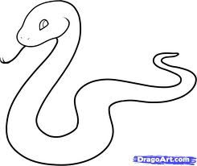

 s t

n h

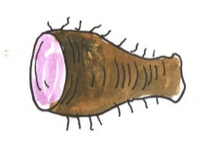

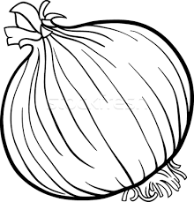 y x

b o

 e a

1. **Form words.**

bo – x = box

pe – n = _________________

le – g = ________________

ba – t = _________________

po – t = ________________

ma – n = _________________

1. **Write words for the sounds.**

box

bo ________________________

si ________________________

ne _______________________

ba _______________________

po _________________________

1. **Name the pictures.**

__________________

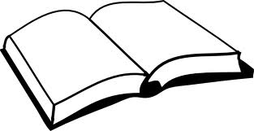

__________________

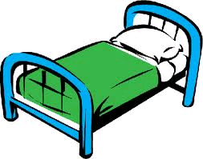

___________________

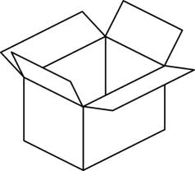

____________________

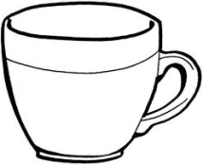

____________________

(cup, bed, book, box, tin)

1. **Copy and write.**

Mm Mm Mm Mm

m m m m m m m m

**z**

**t**

**i**

____________________________________________________________________________________________________________________________________________________________________________________________________________

Mat man moon

____________________________________________________________________________________________________________________________________________________________________________________________________________

Mercy is sitting on the mat

**End**